**Zettabyte PTE Ltd. BE Assessment Instructions**

### **Introduction**

Welcome to Zettabyte! This document outlines the assessment procedure for our BE position. Your participation in this test is critical to determine your suitability and skills in developing and managing the server-side part of the platform within our company.

### **Assessment Objective**

The purpose of this assessment is to evaluate your proficiency in JavaScript for developing and managing back-end systems. We aim to assess your ability to ensure scalability, security, and efficiency in the back-end infrastructure. This will help us understand your capabilities in building and maintaining robust server-side applications.

### **Test Instructions**

You are required to record your screen and have your camera on throughout the test. This shows us the process, ensures you're not cheating, and lets us see your face. You can do this by joining an online meeting (like Zoom, Jitsi or Google Meet), sharing your screen, and recording. **If there is no submission of the recording, you will be disqualified**. Here is an example of the screen recording we expect:

**) If you want to use Jitsi as a screen record, here’s a tutorial on how to use Jitsi: [click here](https://youtu.be/c-IZBJnaraI)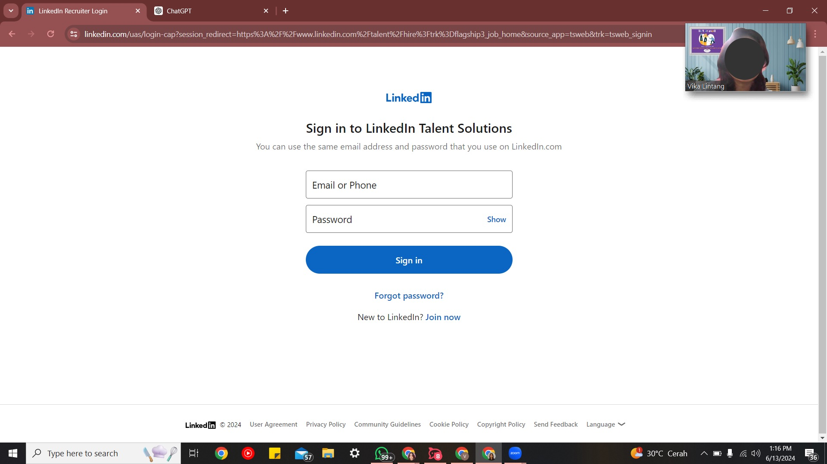

There are 2 kind of test that need to be done:

1. Psychological Test
2. Aptitude test

* Click here: [Aptitude test](https://aptitude-test.com/)
* Click ‘Start Free Test’
* Screenshot your result

1. DISC

* Click here: [DISC test](https://www.crystalknows.com/disc-personality-test)
* Click ‘Get Started for Free’
* Sign up with google account / sign up for free
* Click ‘Begin Assessment’ and take the test
* Download full result as pdf by clicking the ‘print’ button and check all checklist. Make sure you chose the ‘DISC’ option instead of ‘Map’

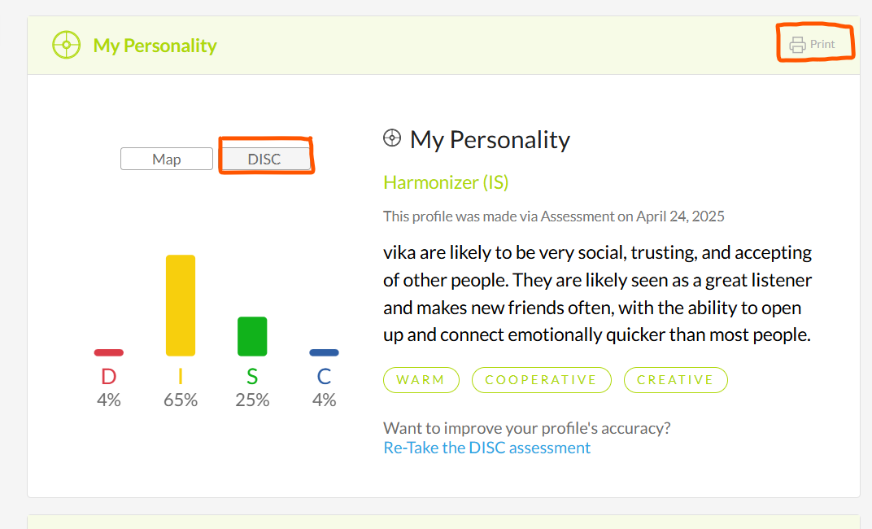

1. Technical Test

* In this section, you will be given tests for knowledge and also a coding test focused on JavaScript.
* Access the test through this link: [JavaScript](https://drive.google.com/file/d/12waHAkeL9TUVQ0ERX5z8DisPDT3aQKIW/view?usp=sharing).
* Once you have completed the test, please upload your result to GitHub.

### **Assessment Submission and Evaluation**

Submit the test by replying to this email in thread and attach **two links:**

**1. GitHub link for test submission**

**2. Google drive link** containing:

a. PDF of Psychological Test result

b. Screen record during the test

Kindly let me know personally via WhatsApp if you have submitted the test.

### **Conclusion**

We appreciate your effort and time in participating in this BE assessment. Your detailed work and reports are invaluable in helping us evaluate your potential contribution to our team at Zettabyte.